Paediatric Speech & Language Therapy Referral Form – Communication Referrals only
(Do not use for Dysphagia, i.e. eating/drinking/feeding/swallowing difficulties, a separate referral form is available)

Referral Guidance Notes
- Please ensure that all sections are completed fully – incomplete referrals will be rejected
- Please check the guidance document to ensure that the child meets the referral criteria for the Children’s Speech & Language Therapy Service
- All referrals must demonstrate a minimum of three months of intervention and support (graduated response) prior to the referral submission. Referrals not demonstrating this will be rejected.

Patient Details: Parents/Carers should ensure that the service has the most up to date information including home address / telephone number / email address / setting information
Child’s first name/s: |  |  |  |  | Child’s Family name:
Date of Birth: |  |  |  |  | NHS Number:
Address: |  |  |  |  | ☐ Male  ☐ Female  ☐ Prefer not to say
Postcode: |  |  |  |  | Preferred Contact Number:
Preferred Email Address: |  |  |  |  | Consent to leave answerphone message: |  |  |  |  |  |  | ☐ Yes  ☐ No
Consent to receive correspondence on this email (reports/appointments/resources etc? |  |  | ☐ Yes  ☐ No
Is this child on a child protection plan? |  |  | ☐ Yes  ☐ No |  | Is this child entitled to NHS treatment? |  |  |  |  |  |  | ☐ Yes  ☐ No
Please indicate the child’s ethnicity: |  |  |  |  | Asian/Asian British- Pakistani |  |  |  |  |  |  |  | ☐
White - British |  |  |  | ☐ | Asian/Asian British – Bangladeshi |  |  |  |  |  |  |  | ☐
White - Irish |  |  |  | ☐ | Any Other Asian Background |  |  |  |  |  |  |  | ☐
Any Other White Background |  |  |  | ☐ | Black/Black British Caribbean |  |  |  |  |  |  |  | ☐
Mixed - White & Black Caribbean |  |  |  | ☐ | Black/Black British African |  |  |  |  |  |  |  | ☐
Mixed – White & Black African |  |  |  | ☐ | Any other Black Background |  |  |  |  |  |  |  | ☐
Mixed – White & Asian |  |  |  | ☐ | Other Ethnic Groups – Chinese |  |  |  |  |  |  |  | ☐
Any Other Mixed Background |  |  |  | ☐ | Other Any Other Ethnic Group |  |  |  |  |  |  |  | ☐
Asian/Asian British- Indian |  |  |  | ☐ | Not Stated |  |  |  |  |  |  |  | ☐
Child’s GP:
Name of GP: |  | Telephone Number:
Address of GP:

Language/s used at home to speak to child:
Language/s used at home: |  |  |  |  |  |  |  | Interpreter needed? |  | ☐ Yes  ☐ No
Preferred Language for Appointments:

Details of all persons with Parental Responsibility:
Name: |  |  |  |  |  | Name:
Relationship to child: |  |  |  |  |  | Relationship to child:
Language spoken by parent: |  |  |  |  |  | Language spoken by parent:
Address:  Postcode:  Contact Number:  Email Address: |  |  |  |  |  | Address:  Postcode:  Contact Number:  Email Address:
Relevant information needed for home visits:

Details of other children/young people in the family:
Names of children in family: |  |  |  |  |  | Dates of Birth:
Medical Information:
Is there a family history of:  Speech, Language and Communication Difficulties |  | ☐ Yes  ☐ No  Relevant details:
Details of the child’s medical conditions, diagnoses and / or allergies

Does the child have an identified hearing loss? |  | ☐ Yes  ☐ No  Relevant details:
Professionals Involved in the child’s care: Please include any relevant reports or letters.
Name/s |  | Title/Profession |  |  |  |  |  |  | Contact Information
Legal Care Status: Please only complete this section if the child has a ‘Looked After’ status.
Name of organisation with parental responsibility (PR):

Designated Contact Person / Social Worker:

Contact Details:
Including contact number, email address, work address
Safeguarding / Risk Management: Please include any relevant information e.g. lone working considerations / health and safety / family safeguarding concerns / parental support needed for appointment letters and reports etc.
Educational Setting: School / Nursery / Childminder
Name of Setting: |  |  |  |  |  |  | Setting Address:
Contact person and role: |  |  |  |  |  |  | Setting’s email address:
When do they attend? | ☐ Full Time  ☐ Part Time |  |  |  |  |  | If part time, what day / time does the child attend?
How is the child progressing in their educational setting? Please include details of support they receive and any other information that you feel is relevant (e.g. EHCP, support plans, reports etc.)

Referrer Details:
Referrer’s name:
(please print)

Referrer’s signature:

Relationship to the child:
(e.g. parent / teacher / SENCO etc.)

Contact details:
(Including address, contact number and email address)
Date of referral:

Parental / Carer Consent: Parental Consent must be indicated for all referrals.
Please advise that consent includes:
- The sharing of information between services relevant to the child.
- The sharing of information via email, including letters and reports. The security of these emails cannot be fully guaranteed
Parent / Carer name:
(please print)

Parent / Carer signature:

If unable to gain a signature, has consent been verbally indicated by parents or those with parental responsibility? |  | ☐ Yes  ☐ No  ☐ Not Applicable (Signed above)
Date of consent:

Please return this completed form to:

Paediatric Speech & Language Therapy
Chelmsley Wood Primary Care Centre
Crabtree Drive
Birmingham
B37 5BU

paediatric.speechlanguage@uhb.nhs.uk

Tel: 0121 722 8010 (Message facility only)

The Child’s Communication Profile:
Communication area |  | What is the child good at? |  |  |  |  |  |  | What does the child need help with?
Attention and Listening
The ability to look at and listen to people and things that interest them

Play
Showing enjoyment of an activity. This may include a range of different toys and non-toy items.
Interaction
The ability to show interest in others.
Understanding
The ability to understand information from others, including gestures, objects, signs, symbols or words
Expressive Communication
The ability to use gestures, objects, signs, symbols or words to get message across
Speech clarity
The ability to use speech sounds in the right places for clear talking.
Stammering
Stammers occur where children find it hard to speak without repetitions or words being blocked.
Other information
Please include any relevant supporting information (e.g. EHCP, support plans, reports etc.)
Referral Goal:
Please comment on what you would like to achieve from this referral |  | Parent / Carer: |  |  |  |  |  |  | Referrer:
Graduated Response: All referrals must demonstrate a minimum of three months of intervention and support prior to the referral submission. Referrals not demonstrating this will be rejected.
What support / strategies have been tried?
How long has this support or strategy been in place?
What progress has been seen?


Supporting Children’s Communication Is Everybody’s Business

Research tells us that the best way for supporting speech, language communication, targets and recommendations is a graduated approach. This is a system used nationally, and it considers how everyone in the child’s environment makes an important contribution to the development of the child’s communication skills.
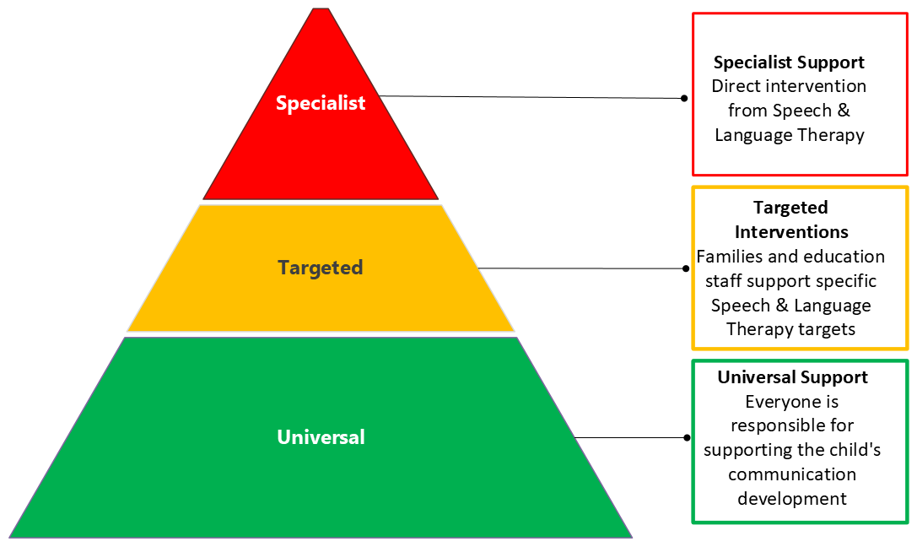 
There are many resources and activities available to support development of all children’s communication skills. Visit local libraries and look at the following websites for support:
 |  | Speech and Language Therapy – Solihull Children's Community Therapies  https://childrenscommunitytherapies.uhb.nhs.uk/speech-and-language-therapy/
 |  | https://speechandlanguage.org.uk/
   |    | https://www.bbc.co.uk/tiny-happy-people  Part of:  https://www.bbc.co.uk/cbeebies/parenting
 |  | https://www.solihull.gov.uk/children-and-family-support/localoffer/Speech-Language-and-Communication-activities
 |  | https://stamma.org/
 |  | https://actionforstammeringchildren.org/

