|  |  |  |
| --- | --- | --- |
|  | | **Seating for children with mild motor difficulties** |
| Marker | Solihull Community Therapies  Occupational Therapy  Chelmsley Wood Primary Care Centre  Crabtree Drive  Chelmsley Wood  Birmingham  B37 5BU |
| Receiver | 0121 722 8010 |
| Email | Paediatric.Occupationaltherapy@nhs.net |
| World | https://childrenscommunitytherapies.uhb.nhs.uk |
|  |  |

The principles of good seating and posture are especially important for children with mild motor difficulties including those with dyspraxia. Getting seating right is a “reasonable adjustment” that will help schools to ensure all children are able to access learning opportunities in the classroom.

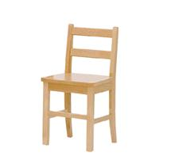

In addition to the tips for good posture provided in another advice sheet it may also be beneficial to provide the following:

* A chair with sides or arms to provide guidance regarding trunk position
* A chair with a full back rest
* A chair with a straight, rather than angled seat and back
* A good, heavy footrest (one that can’t be kicked away)
* A chair than can easily be moved in and out of the table.

Sometimes a suitable chair already exists in the school.

Alternatively, the Occupational Therapist or Physiotherapist may recommend a specialist chair such as those pictured below:

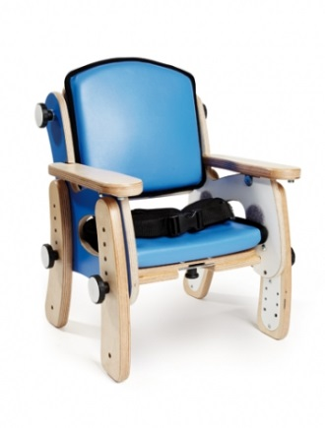

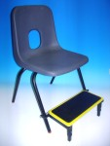

[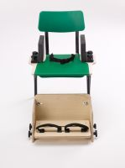](http://liveimageserver.dlf.org.uk/mee/products/full/0027215.jpg)

