

**Home Equipment**

**Information for Parents**



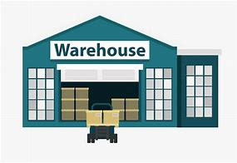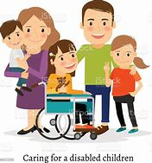

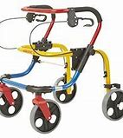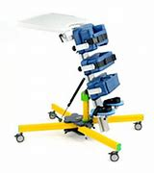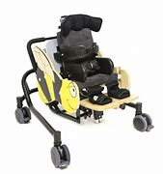

**Your Physiotherapist**

Your Physiotherapist is part of a multi-disciplinary team and will liaise with relevant professionals to ensure your child gets the most appropriate help and support required.

Your Physiotherapist is responsible for overseeing the care of your child in respect of any physiotherapy needs including regular contact to check on progress, advice and guidance regarding positioning, compilation of physiotherapy exercise programmes, referral to other specialist professionals as required, and overseeing any equipment needs for your child.

It is likely that your child has already been referred to our service and a member of the team has already been in contact with you.

Some examples of the type of equipment that your physiotherapist might recommend may include specialist seating, standing frames, walking frames, rolls, benches and sleep systems.

As your child grows, equipment will need to be adjusted and reviewed. An assessment for new equipment will occur if your child outgrows the current equipment

In light of the pandemic, we are conducting intervention in a “virtual first” manner. Therefore, initially children will have equipment assessments and reviews via a video call. If required, an Equipment Rep will attend the home setting to bring new equipment or review existing equipment. If required, a member from the physio team may also be present.

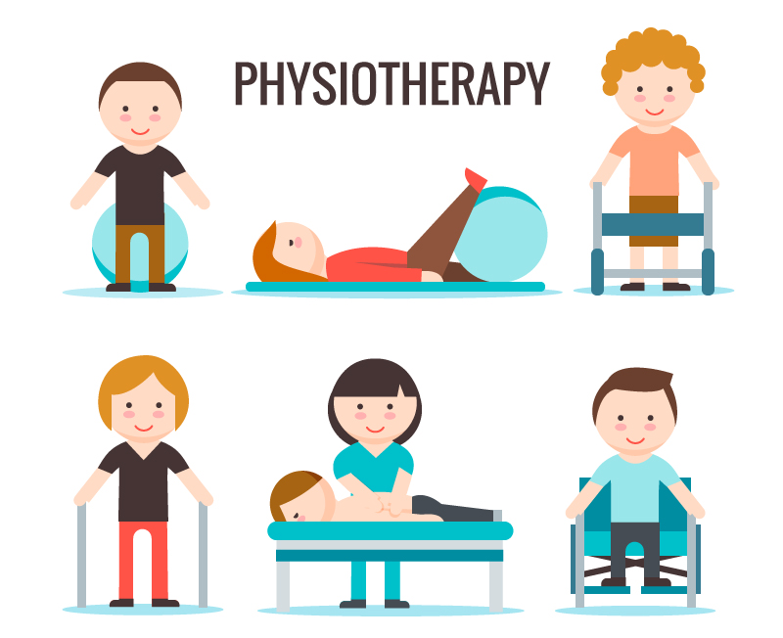

**Assessment/Reviews**

**Visit to the Home Setting by the Equipment Rep**

Your Physiotherapist will liaise with the Equipment Rep and arrange a visit to the home setting for a review of an existing item of equipment or to carry out an assessment for a new item of equipment.

A member of the physiotherapy team will send you an email with a “link” provided, so that a video appointment can be set up virtually. This will then provide a three-way virtual meeting with the Rep, yourselves/your child and a member of the physio team.

**Review of Equipment**

The rep will carry out the review with a member of the physiotherapy team attending virtually and will make any necessary adjustments so that your child is given optimal support in their equipment. As your child grows, these adjustments are necessary for comfort and support. Due to normal wear and tear, parts of the equipment may need replacing so the Rep will submit a quote to your physiotherapist. If you have concerns that the equipment is unsafe or too small for your child, please call your child’s physio to discuss arranging a review.

**Assessments**

If your child needs a piece of equipment or has outgrown their equipment or it has become unsafe for them to use, the Rep will carry out a full assessment with the physiotherapist present virtually. On this visit, it is likely that the Rep has brought a selection of equipment with him/her to establish correct sizing for your child.

The cost of complex specialised seating and standing equipment starts around £4,000 for just one item, so it’s imperative that the measurements are correct.

Due to the cost involved, the service require 2 x quotes for comparison purposes. It may be necessary to have 2 separate Rep visits from different companies in order to select the best equipment.

Once the assessment is complete, the Rep will submit a quote to your physiotherapist.

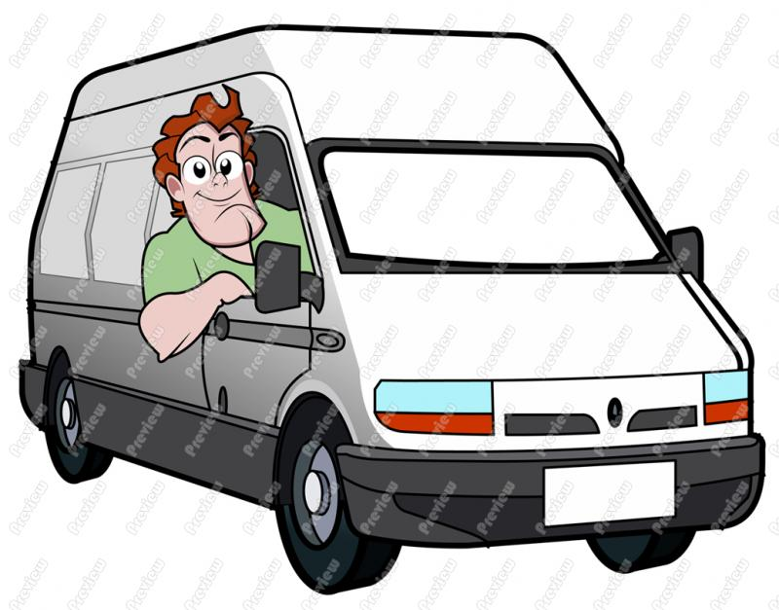

**Ordering and Delivery of Equipment**

**Ordering Equipment**

Following the Rep’s visit to your home, a quote will be submitted to your physiotherapist.

***Items in Stock***

Your physiotherapist will initially investigate whether Community Equipment Stores already have the item in stock. If so, it may be necessary to order specific parts - your physiotherapist will submit the appropriate paperwork to order these items. Stores personnel will arrange for a full service from the equipment supplier and will completely de-sanitize the equipment.

When the additional parts are received into Stores, the item/parts will be scheduled for delivery.

If the items are in stock or are considered to be an “off the shelf” item, then delivery to the home setting can be arranged fairly quickly.

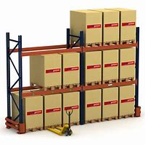

***Items not in Stock***

If the item is not held in stock or is a “bespoke” item, your physiotherapist will raise a request form and must complete this in full, with extensive clinical reasoning before submitting this to Community Equipment Stores. Due to the high cost of specialised/complex equipment, all requests in excess of £1000 require two separate quotes from different companies as a comparison. This often delays the process of ordering the equipment because it means arranging another home visit with a different supplier.

Once the two quotes have been received, all documentation is submitted by your physio to Community Equipment Stores.

**Community Equipment Stores**

The documentation is thoroughly checked by stores personnel as they must ensure that it meets all procurement legislation. Often, this means they are awaiting responses from third parties and of course, this can add to the delays. Once the “checks” have been completed, the documentation requires approval before being submitted to the Administration Team for ordering.

Unfortunately, due to the pandemic/Brexit, there is currently a national shortage of steel/equipment components across both Adult and Paediatric Groups. Some equipment is no longer obtainable for purchase which means that Stores must source new suppliers.

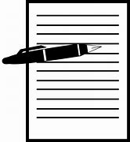

**Delivery of Equipment**

When the item/parts are delivered to Stores, they will schedule delivery to the home setting. For large items of equipment such as specialised Standing frames and some specialised seating, the delivery will need 2 drivers to offload the item from the van to the doorstep. Items will require a signature on delivery.

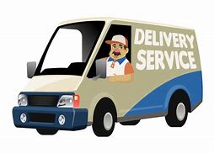 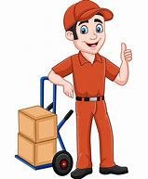

**Timescales**

For “bespoke” or larger items eg Standing Frames/Specialised seating, delivery can take approx. 2/3 months.

**Return of Equipment No Longer Used or Needed**

Due to the pandemic, visits to stores by parents/carers in order to return equipment , are not taking place.

For equipment no longer used, please ring/email Community equipment stores as listed below :

* Telephone : 0121 329 0900 or
* Email : [jointequipmentservice@solihull.gov.uk](mailto:jointequipmentservice@solihull.gov.uk)

Please provide the following information to stores :

* The item to be collected eg chair/standing frame – make and model
* Your child’s name and address

If the item to be returned is a large specialised piece of equipment, this will require 2 members of staff from stores to load it into the van. This journey will need to be planned in, therefore it may take longer for this to be collected from the home setting.

Staff at community equipment stores will arrange for unused equipment to be returned to stores to be deep cleaned, serviced and re-issued to other children as required.

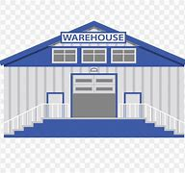

**General Maintenance and Cleaning Guidelines**

**Cleaning Recommendations-**

* Daily use antibacterial wipes to wipe down all surfaces
* Spillages should be removed as quickly as possible after contact. Using antibacterial wipes and/or soap and water on a damp cloth. Dab the stain, do not rub and do not over wet the stain.
* Do not use organic solvents, dry cleaning fluids, abrasive cleaners or industrial bleaches.
* Make sure that the product is dry before use

**Daily Checks-**

* Replace any lost or worn washers or bolts
* Check that the tray (if applicable) secures onto the equipment and there is no damage or rough or sharp corners
* Check all upholstery for any signs of wear and tear
* Brush Velcro® to remove fluff
* Check wooden parts for splitting or splintering
* Check straps for fraying and missing or broken buckles • Clean any stains or spillages

**Monthly Checks**

* Make sure all nuts and bolts are in place and secured.
* Check if any washers/bolts are worn or missing.
* Check that all mechanical movements operate fully- ie. Equipment goes up and down appropriately.
* Check for signs of wear, to include splintering of any wood, bent metalwork, torn/frayed straps or rips/tears to the fabric.
* Check the castors run smoothly when the equipment is pushed and the castors are not loose, bent or worn.
* Wipe down the wheels to remove dirt/grit/grease.
* Check that the brake stops the wheels rotating (where applicable)
* Brush the Velcro® on the straps to remove fluff
* Check straps and missing or loose broken buckles

**Good Sitting Posture**

A good posture is required in seating to provide a stable and balanced position from which activities can be completed independently, ensuring that the body is at the least risk of damage. When sitting with a poor posture, an imbalance of weight distribution can lead to the development of pressure ulcers and other severe physical complications, as well as impeding on function and communication and in turn impacting a person's quality of life and wellbeing. This means that individuals with diminished abilities to reposition to maintain a good posture due to muscle weakness and poor motor control require specialist seating to maintain an optimal sitting posture, reducing the likelihood of these complications developing.

The basis of a good posture comes from symmetry and stability of the pelvis with pressure being transferred through the Ischial Tuberosities (the ‘sitting bones’ of the pelvis). People with neurological conditions typically experience muscle weakness and impaired muscle tone which can impact motor control and mobility, resulting in an increasing difficulty to maintain postural control

**Poor Sitting Posture**

Frequently sitting with a poor posture can lead to muscle shortening, pain, excessive muscle tightness, shaking, uncoordinated movements, communication difficulties, loss of balance, and it can result in a person being less able to carry out functional activities

**What to look out for**

* **ensure child’s bottom is right back in the chair. This will create 90 degree angle at the hip joint**
* **the lapstrap should be tight and firm to ensure little movement at the hip joint**
* **there should be a 90 degree angle at the knee joints with upper legs lying comfortably on the seat**
* **ensure the knees are not raised – if so, lower the footplates**
* **the front of the seat should finish approx 2cm from the knee bend – it should not dig-in to the back of the knees**
* **ensure the footplate is at a 90 degree angle to support the foot**
* **secure the feet in sandals/ankle huggers to prevent legs dangling and causing damage to the hips.**
* **Check that armrests are at the correct height and level to be comfortable for the child**
* **Is child sitting as upright as possible? If child gets tired frequently and slouches, consider a harness/waistcoat**
* **The top of the shoulders should be level with the top of the backrest of chair**
* **Does the child have good head support – if not, consider a headrest**

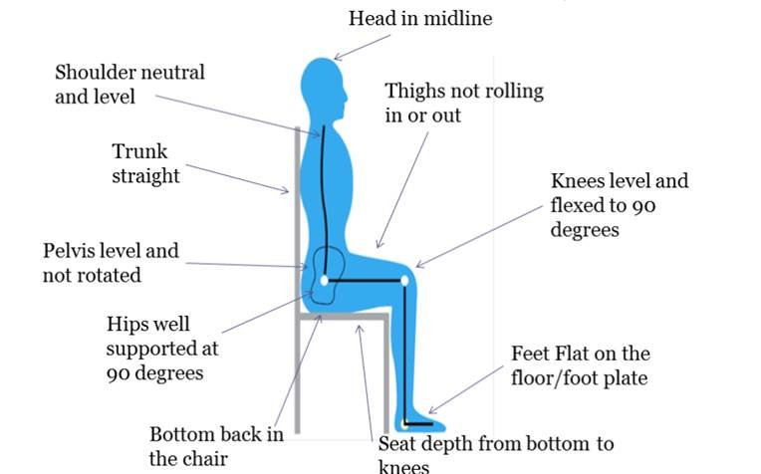

**If in doubt, contact your local physiotherapist for advice – Tel: 0121 722 8010**

9

**Benefits of Standing**

**Bone development -** Taking weight through your bones encourages bone growth and may help to improve bone density. It can also help to form the ball and socket joint of the hips and improve the structure of the joint in early life.

**Kidneys and digestion** - In standing gravity assists the drainage of the kidneys and bladder which is thought to be beneficial. When standing, children can digest their food more easily and may suffer less reflux, indigestion and constipation.

**Circulation and breathing**- Muscle tone is improved with standing and this in turn assists with circulation. The bottom of the lungs can sometimes be squashed sitting down in a chair and can open up more in standing. This means deeper breaths can be taken and more oxygen is available.

**Hand function and posture** - In standing, a child’s body is better aligned, their head control may be better and this in turn helps their ability to play, draw or write.

**Stretching and positioning** - Standing stretches out muscles in the legs and back and allows joints to be straight and properly aligned thus preventing contractures of the hip, knee and ankle. This may help keep better range of movement in these joints for longer and help prevent painful joints in later life.

**Skin** - Standing can help with skin care by relieving pressure caused by sitting for long periods.

**What to look out for**

* **Ensure the child is as symmetrical as possible, with back and hips straight.**
* **Legs should be equally apart and taking weight evenly through both feet**
* **Padding and straps should be tight and firm but comfortable and safe**
* **Ensure child is supervised – this will depend on their level of cognitive behaviour and motor impairment, age and engagement level.**

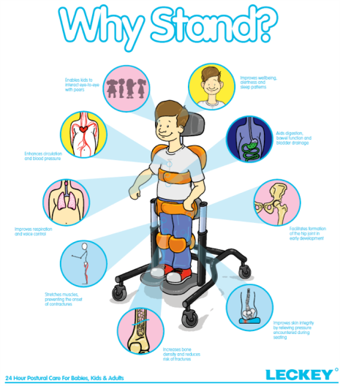

Picture courtesy of Leckey

**Orthotics**

Ankle foot orthoses (AFOs) are used to minimize development of calf muscle contractures, improve walking and standing postures.

For children under 3 years, with little fixed contracture but dynamic tone an off-the-shelf dynamic orthosis that can allow squatting and developmentally appropriate tasks is usually recommended.

Older children require more standard AFOs - those that are made as one piece (static) holding the ankle and lower leg in the correct position.

In some cases, an AFO can comprise of two pieces : a wrap-around inner shell and a solid outer frame.

[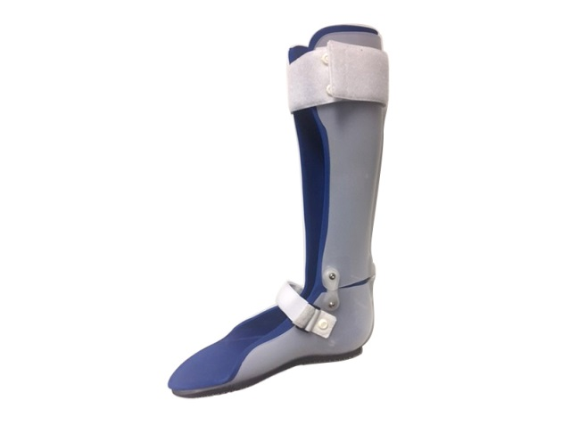](https://www.google.co.uk/url?sa=i&url=https://www.londonorthotics.co.uk/orthotics/bespoke-orthotic-products/&psig=AOvVaw3-FfpPC3bPM6slR6m1RLgj&ust=1601374968782000&source=images&cd=vfe&ved=0CAIQjRxqFwoTCMDLn-PQi-wCFQAAAAAdAAAAABAH)

**Fitting an AFO**

It is often easier to put on an AFO whilst a child has the knee bent, so a sitting position may be the best position to start with.

Place the heel of the foot into the backl of the AFO. This may require gentle mobilisation and stretching of the foot first to ensure that the heel fits into the AFO properly.

Pull and secure the velcro strap across the top of the foot/ankle.

If there is another strap at the toes, then pull and secure this velcro strap.

Finally, pull and secure the strap across the leg just below the knee.

Initially, your child may find the orthotic uncomfortable. To increase comfort levels:

* Make sure the orthotics are securely held and not too loose. Loose fitting device rub and cause skin irritation.
* Periodically check your child’s skin quality. If sore, dark red, blistered, callused, or swollen check to make sure it is secured and fits properly and report to your child’s orthotist.
* If the skin is raw or visibly broken down, the brace should not be used until the skin heals.
* Monitor so that socks do not apply undue pressure, bunching, binding and tightness. Special attention should be made to avoid inside seams and irritating ridges.
* Ask the orthotist how to gradually build up to the suggested daily wear schedule.
* Toes extending beyond the orthotic device or complaints of pain or red markings may indicate that your child is outgrowing their orthotics.
* Ensure proper cleaning, care and storage as per manufacturing instructions.
* Periodically inspect device for cracks, tears, or undue wear.
* Look for parts that may need to be replaced.
* Some children experience excessive perspiration in their device. Changing socks once to twice a day and wearing appropriate sock material will help.

Should you have any concerns, please contact your Orthotist.

**The Use of Measuring Forms**

If you are unsure whether your child has outgrown a piece of equipment at home, it would be useful to complete the relevant form enclosed.

There is one for seating and the other to be used for a standing frame/walker.

Following completion, please email/contact your Physiotherapist who will then liaise with the Rep for advice.

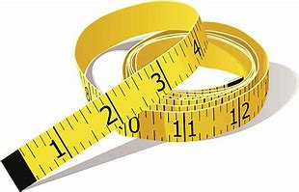

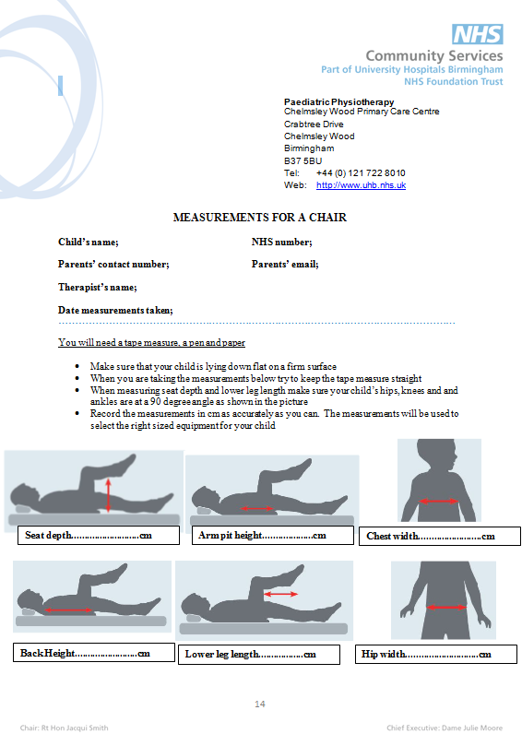

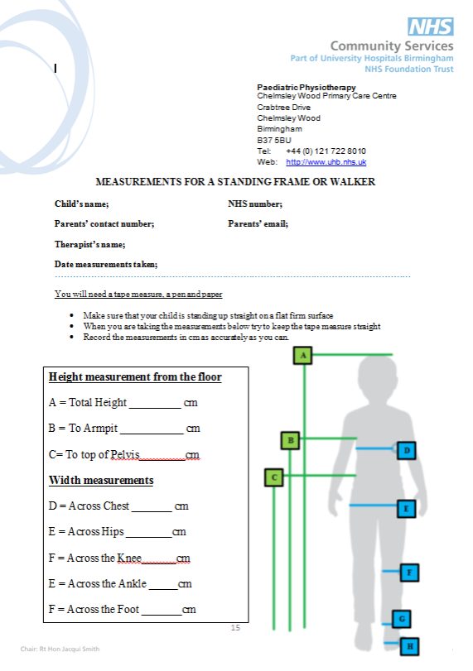

**Useful Links - Equipment Suppliers**

Jiraffe - <https://www.jiraffe.org.uk/products>

Leckey - <https://www.leckey.com/products>

JCM - <https://www.sunrisemedical.co.uk/seating/jcm> (now part of Leckey)

R82 - [www.r82.co.uk/products](http://www.r82.co.uk/products)

Schuchmann - <https://schuchmann.co.uk/products>

Smirthwaite - <https://www.smirthwaite.co.uk>

Quest 88 - <https://quest88.com>

RMS - [Mobility Products | RMS (ineedawheelchair.co.uk)](https://ineedawheelchair.co.uk/mobility-products)

**“How To” - Useful Links for Equipment**

<https://uk.youtube.com/>

The above link to you tube will allow you to enter a supplier name and this will display several videos relating to their different types of equipment and “how to” videos. There are also some educational videos within these sites.