Your Assessment at the
Specialist Assessment Service

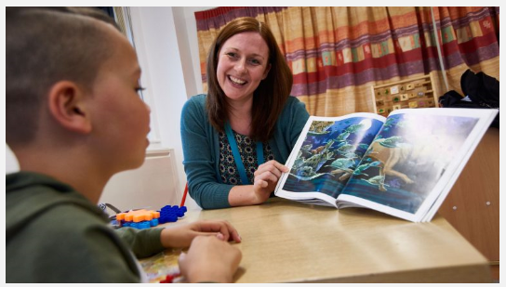
Service User Information

Why are we doing an assessment?
We are a service who assess 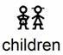 (0-18) for Autism Spectrum Disorder (ASD).

Someone you know thinks you may have ASD and that it would be useful if we can either

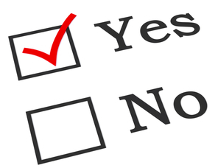confirm or 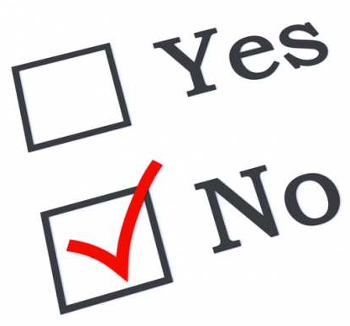rule this out.

You might agree with this

You might not agree with this

We want to find out if you do have Autism.

We have some assessments we can do with you to find out if you have Autism.

What happens at the assessment?

You will come to see us at our clinic. We are based at
Chelmesley Wood Primary Care Centre.
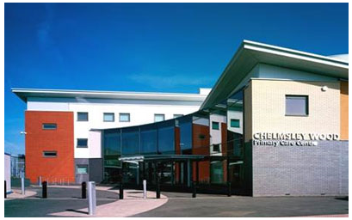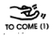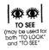

You will wait for someone to meet you from the waiting area.
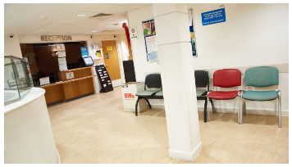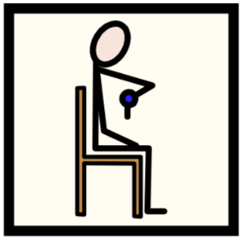

We will then take you to a clinic room with your parents (or without if you feel comfortable)
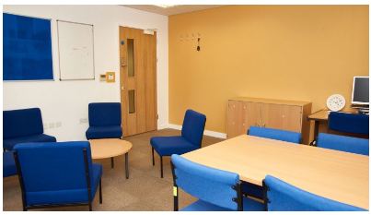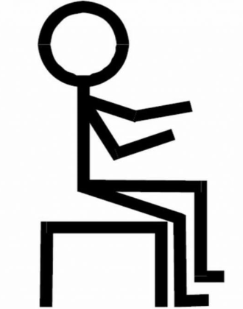

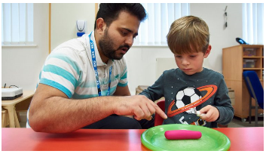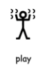
During the assessment you will complete some activities with your specialist.

You may need to attend another appointment following your assessment. 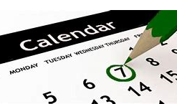

You may need to do more assessment or you may be told if you have autism or not.
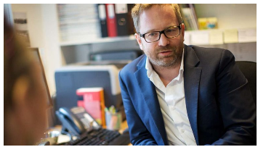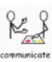

This will help other people to understand your needs and we will need to share this information with your 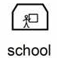 and your parents.
What happens after the assessment?
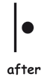, we will ask you for your feedback. We will give you a small yellow ticket to put in one of these boxes, they are near the door
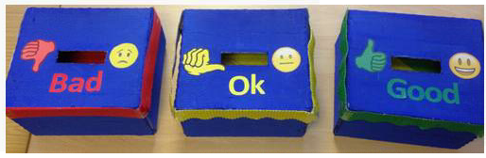
You can also write some comments on a green leaf paper like below
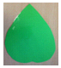We use this information to make sure we are doing our best!

After your assessment you will not need to come back to us.
We will send you a report in the post
You will then know if you have autism or not, and your assessment will be complete
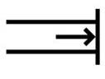
Thank you we are now finsihed

