ASD and mental health and well-being

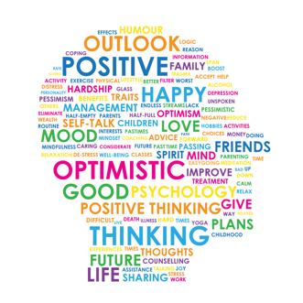

What is mental health?

We all have mental health. The World Health Organization defines mental health:

"Mental health is not just the absence of mental disorder. It is defined as a state of well-being in which every individual realizes his or her own potential, can cope with the normal stresses of life, can work productively and fruitfully, and is able to make a contribution to her or his community."
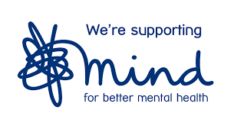
The national Charity Mind states that good mental health is when:

"You care about yourself and you care for yourself. You love yourself, not hate yourself. You look after your physical health – eat well, sleep well, exercise and enjoy yourself.

You see yourself as being a valuable person in your own right. You don't have to earn the right to exist. You exist, so you have the right to exist.

You judge yourself on reasonable standards. You don't set yourself impossible goals, such as 'I have to be perfect in everything I do', and then punish yourself when you don't reach those goals."

Child and Adolescent Mental Health

Children and young people have mental health needs at any age. There is increasing awareness of the fact that children and young people can experience a variety of mental illnesses and this can impact on their friendships and relationships with other people as well as their ability to access education and to engage in activities that they would usually enjoy doing. Often when there is a mental health concern fro a child/young person this can also impact on other family members and can result in the family as well as the young person needing advice and support.

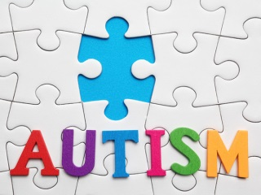
Why does having Autism make someone vulnerable to developing difficulties with their mental health?

It is important to point out that ASD itself is NOT a mental health difficulty/disorder/illness, even though there may be some documents where ASD is listed as a ‘mental health condition’. This is factually incorrect. ASD is a neurodevelopmental difficulty resulting in difficulties with social communication and interaction, as well as flexibility of thought and behaviours.

However, some of the traits that a person with an ASD may have, may result in them being vulnerable to developing difficulties with their mental health:

- Difficulties with Social Communication
- Difficulties with Social Relationships
- Inflexibility in thinking; difficulties processing information, need for sameness and routine, difficulties with change, literal understanding of what other people say, misinterpretation of what other people say and do
- Sensory processing differences; being either over sensitive/under sensitive/both to sensory information being processed, impacting on emotions, mood and behaviour

How do I support someone with their mental health?

The national charity Young Minds recommends the following things if you are worried about the mental wellbeing of someone with ASD.
Firstly it is “important to talk to them, and encourage them look after themselves and seek specialist help if needed.” People with ASD “might find it harder to communicate how they feel, so here are some tips that can help you to have a positive conversation:
•Try to talk in a quiet, calm environment. Background noise, fluorescent lighting – even the sound of you stirring your tea – can be really distracting and make a difficult conversation much harder.
•Find out what kind of communication works for them. It can be helpful to ask your friend how they prefer to communicate. Some people may prefer to text, or write something down, or to have time in advance to think about their answers.
•Ask closed, direct questions: People with ASD can find open questions such as ‘How was your day?’ much harder to answer than something more defined, like ‘Did anything happen today that upset you?’
•Allow enough for them to answer: People with ASD may take some time to process your question and respond to it. When waiting for an answer it might feel tempting to ask the question again, or rephrase – silences can feel awkward! Instead, give your friend plenty of time to respond, and be OK with the silence.

Protective Factors for mental health if a person has an ASD:

- Personal factors:
  - ‘easy’ temperament
  - absence of challenging behaviour
  - good verbal reasoning skills
  - insight
  - motivated to change
  - cognitive flexibility
  - openness to new ideas

- Contextual factors:
  - supportive school environment
  - supportive family environment
  - calm consistent parenting style
  - high parental self-efficacy and self-esteem
  - good understanding of ASD
  - friendships

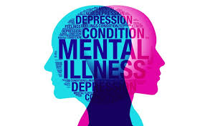
Types of mental illness:
Your Autism Magazine, Vol 8(4), Winter 2014. provides information on ASD and mental illness. Information taken from this source is summarised by the National Autistic Society:

Anxiety disorders 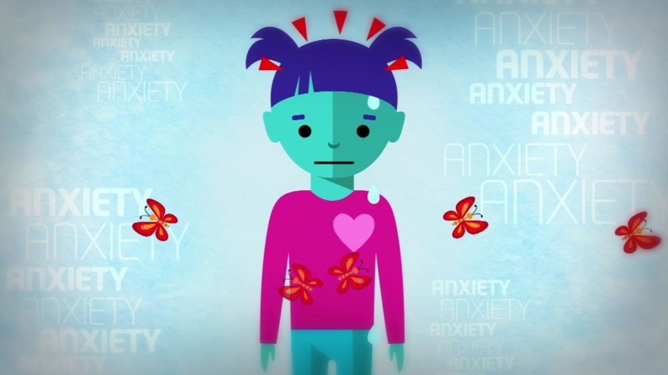
It is understood that young people with an ASD experience higher levels of anxiety than the general population. However, this understanding can often result in the diagnosis of ASD overshadowing the fact that the anxiety is reaching levels that requires further assessment for the possibility of an additional anxiety disorder. They key to knowing when to seek additional help and support is to listen to families; if they report symptoms that are more than what they typically see in the person with ASD, then this means that they need further assessment for the possibility of an additional anxiety disorder.

Anxiety disorders are very common amongst people with ASD. Roughly 40% have symptoms of at least one anxiety disorder at any time, compared with up to 15% in the general population. Understandably, this can lead to sadness or depression – one reason why a mixture of anxiety and depression is common.

Types of anxiety disorder are:
- Generalised anxiety disorder (GAD) – this means having regular or uncontrollable worries about many different things in your everyday life. Because there are lots of possible symptoms of anxiety this can be quite a broad diagnosis, meaning that the problems you experience with GAD might be quite different from another person's experiences.
- Social anxiety disorder – this diagnosis means you experience extreme fear or anxiety triggered by social situations (such as parties, workplaces, or any situation in which you have to talk to another person). It is also known as social phobia.
- Panic disorder – this means having regular or frequent panic attacks without a clear cause or trigger. Experiencing panic disorder can mean that you feel constantly afraid of having another panic attack, to the point that this fear itself can trigger your panic attacks.
- Phobias – a phobia is an extreme fear or anxiety triggered by a particular situation (such as social situations) or a particular object (such as spiders).
- Post-traumatic stress disorder (PTSD) – this is a diagnosis you may be given if you develop anxiety problems after going through something you found traumatic. PTSD can cause flashbacks or nightmares which can feel like you’re re-living all the fear and anxiety you experienced during the actual event.
- Obsessive-compulsive disorder (OCD) – you may be given this diagnosis if your anxiety problems involve having repetitive thoughts, behaviours or urges.
- Health anxiety – this means you experience obsessions and compulsions relating to illness, including researching symptoms or checking to see if you have them. It is related to OCD. (You can find out more about health anxiety on the Anxiety UK website.)
- Body dysmorphic disorder (BDD) – this means you experience obsessions and compulsions relating to your physical appearance.
- Perinatal anxiety or perinatal OCD – some women develop anxiety problems during pregnancy or in the first year after giving birth. (See our pages on perinatal anxiety and perinatal OCD for more information.)

It is thought that a combination of factors, leading to vulnerability to stress, is likely to explain why anxiety disorders are so common for people with ASD. Biological differences in brain structure and function, a history of social difficulties (leading to decreased self-esteem and a tendency to think of threats as greater than they are) and problems with finding flexible responses to apparent threats are all likely to contribute.
Many people with ASD may have difficulty describing the symptoms they experience. A sudden change in behaviour could mean they have developed an anxiety disorder, even if there is no complaint of the typical symptoms.
Treating anxiety disorders
Most of the time we learn to cope with difficult situations, whether or not we have ASD – often by "sitting it out" and learning that we have not come to harm from the situation that worried us.
However, if we have an anxiety disorder, we are more likely to try to escape from the difficult situation. This leads to a greater fear of the same situation and an even earlier escape the next time it occurs. In other words, anxiety tends to build on and reinforce itself. It is important to try to break this vicious cycle, and this is why cognitive (to do with thoughts) and behavioural psychological treatments are often as important in treatment as medication.
Usually these treatments involve forming a working relationship with a therapist, building up any necessary skills, and deciding to work through a set of challenges (involving exposure to an aspect of the feared situation) one step at a time that are anxiety-provoking but not intolerable. This way both the mind and the body learn that the feared situation isn't as dreadful as was thought, and this leads to a gradual reduction in anxiety. Such an approach is often very effective. Mind's website has further information about common anxiety disorders. Alternatively more information can be found on https://www.autism.org.uk/about/behaviour/anxiety.aspx

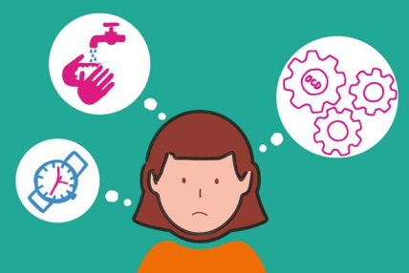
Obsessive compulsive disorder (OCD)
OCD is an anxiety disorder. If someone has OCD, it means that they experience repetitive thoughts and behaviours that are upsetting to them. OCD occurs in about 2-3% of people in the general population and is more common in people with ASD. It is thought that our genes (DNA) and our psychological predisposition can make us vulnerable to developing OCD, which can run in families. OCD can be distressing, exhausting and can get in the way of everyday life for the person who has it and their families. However, it is treatable.
There are two main parts to OCD: obsessions (thoughts) and compulsions (behaviours). OCD can be overlooked in people with ASD as it may be mistaken for a repetitive behaviour. However it is very different. If you think that you have OCD, let your GP know about your concerns. They will help you think about what to do and can refer you for a specialised assessment to help work out what may be OCD (or not) and what may be ASD. Although there is increasing awareness of OCD, it is still under-recognised and therefore under-treated. If you have ASD and think that you may have OCD, it's best to get an assessment and treatment by a team that specialises in both autism and OCD.
Treating OCD
There are two recommended treatments for OCD: Cognitive Behavioural Therapy (CBT) and medication. CBT gives you tools to help you change the way you think and act. As the most researched psychological treatment for OCD, there is now evidence that specialised CBT is effective for treating OCD and anxiety in people with ASD.
Medication can be used either alone or in combination with CBT. The types of drugs that are usually prescribed for OCD are called Selective Serotonin Reuptake Inhibitors, or SSRIs. These include drugs like Fluoxetine (trade name Prozac) and Paroxetine (Seroxat). Some autistic people can be vulnerable to side-effects from medication and so it’s best to start with a low dose, which you and your doctor can increase slowly over time if needed, monitoring your symptoms with an OCD monitoring scale.
Information about autism and OCD (psychoeducation) and social skills work can also form part of a helpful package of individualised care for people on the autism spectrum and OCD.
MIND’s website has further information about OCD.
Depression 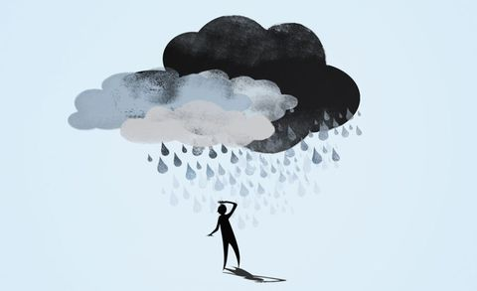
It is very common to have times in our lives when we feel a bit sad or low. But when these feelings last for more than a few weeks and get in the way of day-to-day functioning, this can indicate a period of depression. This is no difference between the general population and people with ASD. It is estimated that at least 20% of the population will experience a period of depression at some point but it is even more common in people with ASD. People who are depressed can experience a range of symptoms which vary from person to person in their combination, and can be mild or severe.
It may be especially hard for depressed people with ASD to seek help because they might find change daunting and anxiety-provoking, feel worried that they will be blamed, or feel unsure about how to describe their symptoms. Anxiety and depression can also make people more generally introverted, withdrawn and isolated. All people with depression may have difficulty sharing their thoughts and feelings. But because people with autism can have difficulty labelling their feelings, it can be especially hard to communicate symptoms or concerns.
Read more about the causes and treatment for depression on the Mind website.
Treating depression
Treatments for depression can be psychological or medical, regardless of whether a person has ASD.
The most important step to getting help is for the person to tell someone they trust, such as a family member, a close friend, their GP or another professional. Some people need a referral to a specialist service, either because they would benefit from psychological therapy adapted for autistic people, or due to a more complex set of problems.
Anxiety disorders, OCD and depression are just a few of the mental health problems people with ASD may experience. For more information on other types of mental health problems, you may find it useful to visit the websites listed below.
Further information that can be found online:
- Mind
  - www.mind.og.uk
- Young Minds
  - www.youngminds.org.uk
- OCD Action
  - www.ocdaction.org.uk
- OCD Youth
  - www.ocdyouth.org.uk
- SANE
  - www.sane.org.uk
- Mental Health Foundation
  - www.mentalhealth.org.uk
- CALM (Campaign Against Living Miserably)
  - www.thecalmzone.net
- Childline
  - www.childline.org.uk
- NSPCC
  - www.nspcc.org.uk
- Solar – Solihull’s Child and Adolescent Mental Health Service
  - www.bsmhft.nhs.uk/our-services/solar-youth-services
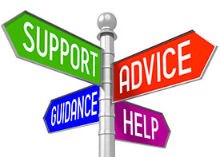
Solihull Mental Health Services and Support
Further information about local services and support for mental health across the whole life span can be found on the local offer webpage:

https://socialsolihull.org.uk/localoffer/?s=mental+health

You can access the full directory of services by clicking on:

https://socialsolihull.org.uk/localoffer/family-information-service-directory/?wpbdp_view=search&kw=mental+health

The service are categorised by need and you can sear through drop down menus to identify any suitable services and support.

Solihull Young Persons Online Service - Kooth.com

Working with Solihull CCG, the Council has commissioned a new resource in Solihull to support Young People with their emotional and mental health and wellbeing.

Kooth.com is a safe, confidential and non-stigmatized way for young people to receive free counselling, advice and support on-line. This very popular service is used by large numbers of young people across the country and delivers 1000s of counselling sessions each year. Staffed by fully trained and qualified counsellors and available until 10pm each night, and weekends from 6pm – 10pm, 365 days per year, it provides a much needed confidential and instant access service for young people aged 11-25.

This includes:
- A chat function for a young person to drop in to speak to a readily available counsellor
- A messaging function for young people to contact the service
- A schedule function to provide booked sessions with a named counsellor on a regular basis
- A range of forums, all of which are pre-moderated, to offer facilitated peer support for CYP.
- Live discussion groups – run by professionals (with all comments moderated) to enable groups of CYP to interact with each other in a safe environment
- An online magazine will full content moderation, creation and editing which includes opportunities for CYP to submit their stories or write articles, all of which is moderated
- Information, activities and self-care tools and resources on the site for CYP to download.

The service is managed by Kal Johal (kjohal@xenzone.com 07957 991673) and Abdul Majid will be the person responsible for ensuring services and young people know how to access Kooth.com. Abdul Majid or Kal Johal will be making contact with services to talk about Kooth, what they will be offering and how young people can access the online provision.

If you would like more information or if you would like Abdul Majid to present to the staff team or at school assemblies, please contact Abdul by phone on 07949 819503 or email me at Amajid@xenzone.com.

Birmingham Mental Health Services and Support

Forward Thinking Birmingham has a resource, which has links for all local CAMHS, and details of support organisations.

The link for this: https://www.simplifyhealth.co.uk

Also, please see this website https://the-waitingroom.org/ which contains health and wellbeing links for pretty much everything/

